First Lutheran Church Anniversary Ornament Sale
First Lutheran Church Christmas ornaments are on sale now, just in time for the holidays! These Christmas ornaments are to commemorate the 100th anniversary of our church building. We worked closely with Wendell August Forge to create these beautiful ornaments. A must have for every Christmas tree this season!
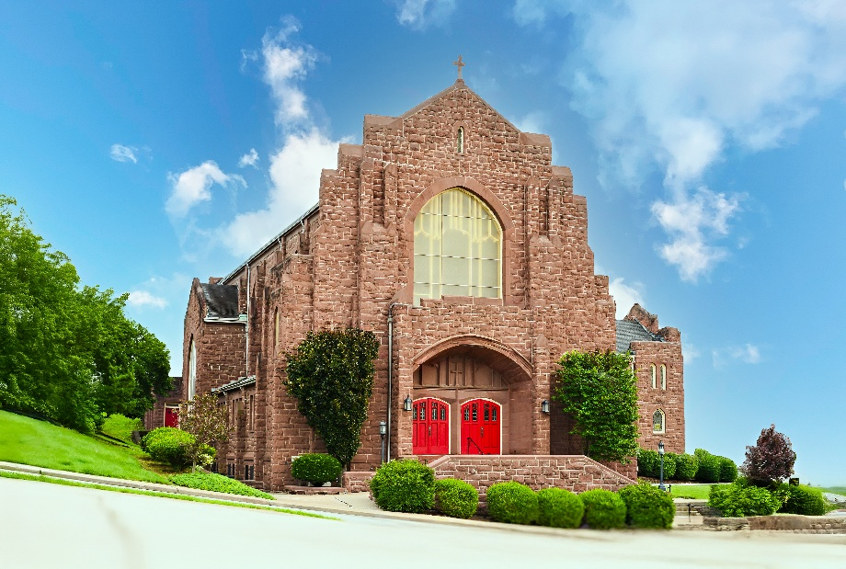
Each metal ornament has an image of the church building stamped into the metal. The ornaments come in an envelope with an insert which has a photo of the church on one side (see below), and some historical information about the church building on the other.

$20 a piece

Name: __________________________________________

Quantity: _______________________________________

Phone: _________________________________________
For those who attend church on-line and wish to purchase an ornament, please contact Heather Quedenfeld 724-263-3253 heather.quedenfeld@comcast.net or Linda Coleman 724-225-8011 ljcjmc@comcast.net

